**Historical Attractions**

**Miguel López de Legazpi monument**

Miguel López de Legazpi, also known as El Adelantado and El Viejo (The Elder), was a Basque-Spanish navigator and governor who established the first Spanish settlement in the East Indies when his expedition crossed the Pacific Ocean.

Location: Legazpi Blvd, Legazpi Port District

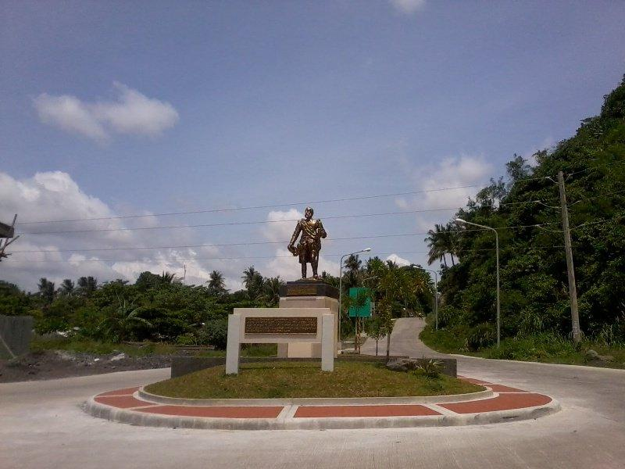

**Battle of Legazpi Pylon**

It is a memorial to the valiant defense of Albayanos against American invaders in 1900. The Battle of Legazpi Pylon is one of the monuments that continue to give the Albayanos a sense of pride – and the whole Filipino nation to cherish and remember.

Location: Intersection of Quezon Avenue and Rizal Street, Barangay 26- Dinagaan, Legazpi Port District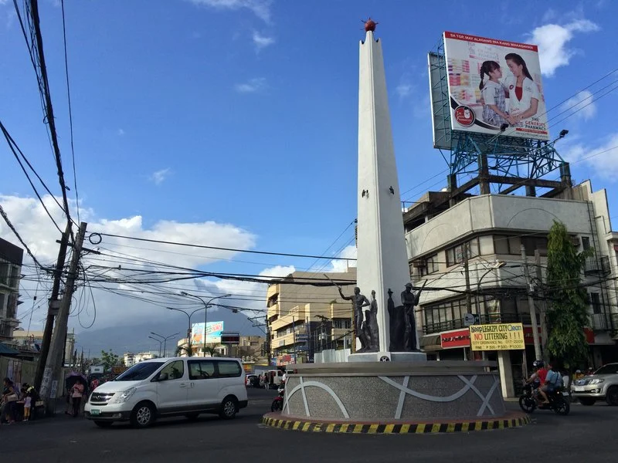

**Headless Monument**

The monument was constructed as a dedication to the unknown heroes who died and shed their blood during the Japanese military occupation in Legazpi City.

Location: Legazpi Port District

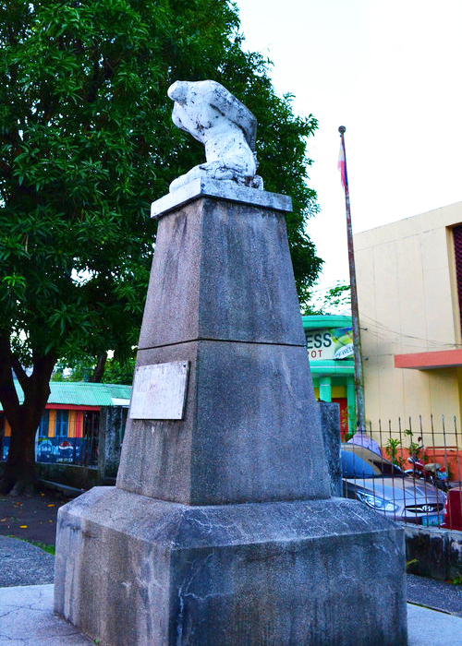

**Jose Ignacio Paua Monument**

Chinese mestizo general in the Philippine Revolution and leader of the expeditionary force to the Bicol Region.

Location: Gen. Jose Ignacio Paua Park along Rizal Avenue

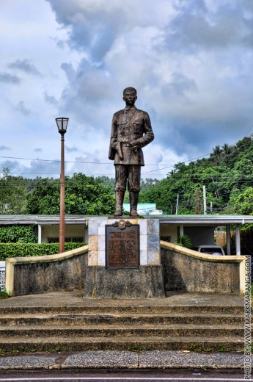

**Ibalon Monument**

An honor of Ibalong mythical, Baltog, Handyong, and Bantong.

Location: Legazpi Blvd, Legazpi Port District

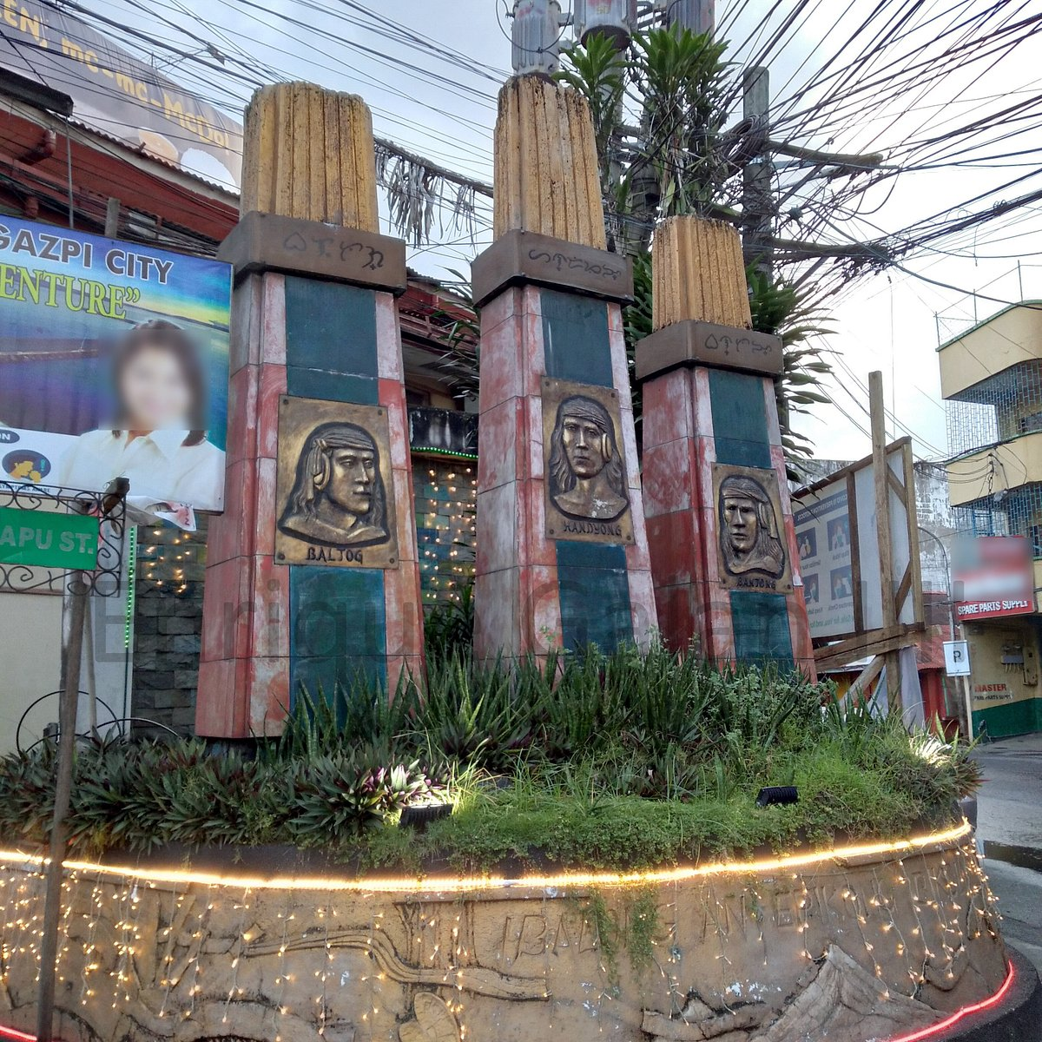

**Liberty Bell**

A gift of the United States of America to Albayanos after World War II.

Location: Peñaranda Park, Rizal Avenue, Old Albay District

